2024年富邦人壽管理博碩士論文獎投稿格式說明
The Format of the Fubon Life Management Doctor and Master Thesis Award
Abstract
This article is from the Chinese Management Association to serve as an example for the format of 2024 Fubon Life Management Doctor’s and Master’s Thesis Award and is provided to applicants as a reference. Theses submitted to this award will be assessed by its assessment committee. Both Mandarin and English theses are welcome. In principle, a doctor’s thesis should be 15 to 30 pages in length (excluding abstract) and master’s thesis should be 10 to 20 pages in length (excluding abstract). Regarding the submitted files of the thesis, both Mandarin and English thesis should include Mandarin and English title and abstract in the first page. The font of Mandarin characters throughout the article should be “DFKai-sb”, while English characters and numbers should be “Times New Roman”. The title of the thesis should be font size 20, level 1 title in the text should be font size 16, level 2 title should be font size 14, while other secondary level text should be font size 12. For further details on the format of the submitting thesis, please refer to the following content. Regarding page number, please start numbering from the text of the thesis. Please use Arabic numerals at the bottom of the page, font “Times New Roman”, font size 10, and aligned center.
Keynote：CMA, Fubon Life, management, Thesis Award (Up to 5 keywords)

- Foreword
The 2024 “Fubon Life Management Doctor’s and Master’s Thesis Award”, sponsored by Fubon Life, is the largest annual nationwide doctor’s and master’s thesis award held by Chinese Management Association (“CMA”) for management professionals. CMA expects that this event can promote the flow of knowledge within the domestic academic circles on management, enhance the exchanges between outstanding management elite students and corporations of Taiwan, and thus achieve the interaction of knowledge, talent, industry and academy.
CMA held the first Management Master’s Thesis Symposium on June 1991. Upholding the idea of giving back to society and the academic circle of management, it has continued to hold thesis award events to encourage domestic management relevant postgraduate students to aggressively dedicate themselves in the writing of high quality theses. Since the event was held, it has been highly praised by society and the number of submitted theses has increased over the years. Currently, it has become the most highly anticipated annual event among domestic university faculties and students and the public. This year, the participants can submit thesis which meets the following 7 categories:
- Business and strategy management (corporate social responsibility, strategy management, business management and strategy management, technology management, innovation management, international corporate management, public administration etc.)
- Marketing management (digital and social media marketing, marketing communication, consumer behaviors, brand management, smart business new retailing, customer relationship management etc.)
- Financial, accounting and risk management (financial management, financial market, financial accounting, auditing, tax affair research, corporate governance, corporate social responsibility, risk and insurance management, fintech, green financing etc.)
- Human resource management and organization behaviors (strategic human resource management, micro human resource management, leadership, team dynamic, innovation and creativity etc.)
- Information management and innovative application (artificial intelligence, IoT, big data analysis, information management strategies, information technology planning and management, e-commerce, innovation management, information security, knowledge management, deep studying, AR/VR, fintech, smart retailing etc.)
- Operation and supply chain management (operation/business management, supply chain management, production management, quality management, business data analysis, smart manufacturing, digital transformation, green supply chain, intelligent logistics etc.)
- Service management (tourism and recreation management, hospitality management, sport management, health care management, service science, MICE management, high-tech service management, long-term care service etc.)
We anticipate that through the holding of this event, we can promote and spur the knowledge reformation and innovation on different fields of management research. “2024 Fubon Life Management Doctor’s and Master’s Thesis Award” is open to thesis submission from May 13 to 18:00 PM of July 16. We welcome postgraduate students (including on-the-job postgraduate students) from management relevant departments throughout Taiwan to participate (for thesis format, please to refer to the following contents).
2. Thesis Format
Layout out should be A4 while the boundary should be standard, in which the lower and upper boundaries should be 2cm and the left and right boundaries should be 2.5cm. All theses should be presented in single column, including the text, figures, charts and references. The PDF file of submitted doctor’s thesis should include 1 page of abstract (including thesis title) and 30 pages of text (including references). The PDF file of submitted master’s thesis should include 1 page of abstract (including thesis title) and 20 pages of text (including references). Those that exceed the regulated pages will not be assessed. Please use “DFKai-sb” font for all Mandarin characters in the thesis, while “Times New Roman” font should be should for all English characters and Arabic numerals. The title of the thesis should be font size 20, level 1 title in the text should be font size 16, level 2 title should be font size 14, while other secondary level text should be font size 12. For thesis format, please refer to the following. Participants can directly use the thesis example enclosed in this file. Regarding page number, please start numbering from the text of the thesis. Please use Arabic numerals at the bottom of the page, font “Times New Roman”, font size 10, and aligned center.
- Cover Page
Please anonymize your thesis is advance. The cover page can only present thesis title and abstract. Name, school, department of the participant cannot be presented on the cover page. Name of instructor (including questionnaire) can also not be presented. Those who failed to anonymize will be disqualified.
2.1.1 Thesis Title
Both Mandarin and English thesis title should apply font size 20, “DFKai-sb” and bold font. Use “DFKai-sb” font for Mandarin and bold “Times New Roman” font all English, both should be aligned center. For the line spacing of the title, please use “single”, in which there will be the space of 1 line between the paragraphs in front and rear.
2.1.2 Abstract
A. “Abstract Title”: Font size should be 14, line spacing should be “single”. It should be 5 lines apart from the front paragraph and 0.5 lines apart from the rear paragraph.
B. “Abstract Text”: Font size should be 14. The first row should be indented by 2 characters. Line spacing should be “single”. English abstract should not exceed 200 words in principle.
C. “Keywords”: Font size should be 14, bold, and italic type. Please do not provide more than 5 keywords.
- Text Title
The numbering system of all titles and text should adhere to the following: 1., 1.1, 1.1.1, A., and a. Level 1 title should be font size 16, bold and aligned center. Level 2 title should be font size 14 and aligned left. The rest of the titles should be font size 12. The line spacing of all titles should be “single” and 0.5 lines apart from the previous paragraph.
Example is as the following:

1. (Font size 16, bold, aligned center)

1.1 Aligned left (Font size 14, bold)

1.1.1 Indented 1.5 characters (Font size of the following layers of titles are 12)

1.1.1 Indented 2.5 characters

A. Indented 3 characters

a. Indented 4 characters

3. Format of Figures and Charts
Title of the chart must be on top of the chart, aligned center, font size 12, line spacing should be “single”, and 0.3 lines apart from the previous paragraph. The configuration of the lines and rows within the chart can be adjusted accordingly. Title of the figure must be below the figure, aligned center, bold, line spacing should be “single”, font size 12, and 0.3 lines apart from the previous paragraph. Title of figures and charts should be indicated with Arabic numerals. Please make figures and charts stay in the same page as possible.
Chart 1 Annual Event Schedule
Items | 2024
● Registration Starts (accepts only online application  ● Accepting Submitted Theses (online submission):  - The registration, information amendment and PDF file uploading functions of the online registration system will be closed on 18:00 PM of July 16. | May 13 - July 16  18:00 PM
Qualification Assessment | July 17 - July 23
Preliminary Assessment | July 24 - July 31
Second Round Assessment | August 2 - August 16
Finalists Announced:  List of finalists will be announced on the event website. Those who failed to enter the list will not receive any notification. | August 21
Notification on Time of Finalist Theses Assessment:  After the list of finalists is announced on the event website, finalists will be notified with their thesis presentation time via e-mail. | August 21 - August 23
Final Assessment:  Participants should present their thesis on the notified designated time. CMA will form an assessment committee for assessment. | August 31 (Sat.)
Awarding Ceremony: Winners will be announced, presented with awards, and a tea banquet will be held. | September 14 (Sat.)

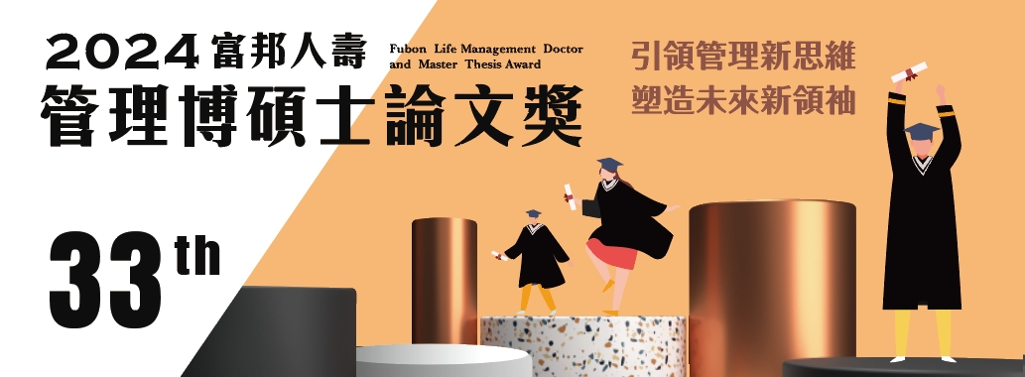

Figure 1 2024 Fubon Life Management Doctor’s and Master’s Thesis Award
4. Reference
References should be arranged in alphabetical order. Literature can only be listed as reference if actually quoted in the thesis. All literature quoted in the thesis should be listed in the reference. Please maintain consistency on the format of reference.
Characters of the reference should be font size 12, justified, the first row should outdent 2 characters, English font should be “Times New Roman”, there should be 0.2 space between the previous and rear paragraphs, and line spacing should be “single”.
Reference (Sample)
Boyer, E. L. 1990. Scholarship reconsidered: Priorities of the professorate. Princeton, NJ: Carnegie Foundation.
Simpson, H. B. 1988. Manic-depressive behavior in early childhood. Unpublished doctoral dissertation, University of Illinois, Urbana-Champaign.
Wallendorf, M. 1987. On intimacy. Paper presented at the American Marketing Association Winter Educators’ Conference, San Antonio, TX.
Schellekens, G. A. C., Verlegh, P. W. J., & Smidts, A. 2010. Language abstraction in word of mouth. Journal of Consumer Research, 37(2): 207-223.

